1.Write a java program called Assgnment1.java that reads a list of costs for a few items. Then, your program
should calculate the best price for the “buy-two-get-one-free” deal.

Input format: This is a sample input from a user.

The first line (= 5 in the example) indicates the number of items for you to buy. The second line presents
the costs of five items. Note that if you buy two items with your money, you can get one item free. For
example, let’s say that you buy the first two items (= 2 and 7) with your money. Then, you can choose
one item for free. Let’s say that you select the item with the cost 6 for free. After that, there are two items
left (= 5 and 5). Since you have to buy the two items anyway, you have to buy them with your money. In
this case, you have to pay total 19 (= 2, 7, 5, and 5).

Sample Run 1: Assume that the user typed the following lines
5
2 7 5 6 5
This is the correct output. If you buy the items 2 and 5 with your money, you can get the item 7 for free.
Then, you should buy the items 6 and 5. Thus, it will be 18.
18

Sample Run 2: Assume that the user typed the following lines
3
10 30 20
This is the correct output.
30

2. Write a java program called Assignment2.java that reads a positive integer number from a user and displays all binary numbers from 0 to the number, you can assume that the input number is a number between 0 to 100.
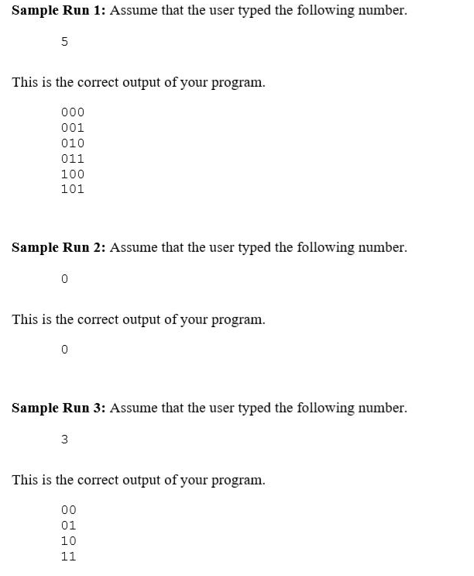

3. Write a java program called Assignment3.java An onion array is an array that satisfies the following condition for all values of j and k:
If j>=0 and k>=0 and j+k=length of array and j!=k then a[j]+a[k]<=10

Your Solution must not use a nested loop. Furthermore, once you determine that the array is not an onion array your method must return 0; no wasted loop cycles please.

Int isOnionArray(int[] a)

Sample Input:
{1,2,19,4,5}
Output : Method returns 1
Reason: because 1+5<=10, 2+4<=10
Sample Input:
{1,2,3,4,15}
Output: Method returns 0
Reason: because 1+15 > 10

- Write a java program called Assignment4.java.
A number n is triangular if n==1 +2+….+j for some value of j.
Write a method int isTriangular(int n) that returns 1 if n is a triangular number,
otherwise returns 0.
The first 4 triangular numbers are 1 (j=1), 3 (j=2), 6 (j=3), 10 (j=4).

